ICS344-03 Project
Saad W.(202337730) and Mohamed K.(202338790)
http://dvsa-website-project-238043187633-us-east-1.s3-website.us-east-1.amazonaws.com/cart
US-EAST-1
13-4-2026
Lesson 1: Event Injection and Lesson 9: Vulnerable Dependencies

Goal and Vulnerability Summary

This lesson demonstrates an Event Injection vulnerability caused by unsafe deserialization of attacker-controlled input in the DVSA application. The main affected component is the request-processing logic inside the AWS Lambda backend, which handles incoming API requests from API Gateway. The vulnerability allows an attacker to inject malicious serialized data into the request body, which is then interpreted and executed as JavaScript code during deserialization. As a result, the attacker can achieve arbitrary code execution within the Lambda environment. The main weakness is the use of an insecure deserialization method (node-serialize) on untrusted input, which treats request data as executable content instead of plain data.

Why This Works / Root Cause

This vulnerability occurs because the backend uses the node-serialize library to unserialize user-controlled input from the HTTP request without validation. Specifically, the application calls serialize.unserialize(event.body) on incoming request data. The node-serialize library supports a special format ($$ND_FUNC$$) that allows serialized functions to be reconstructed and executed during deserialization. Because no validation or sanitization is performed before deserialization, an attacker can craft a payload containing a malicious function, which is then executed automatically. This results in arbitrary code execution inside the Lambda function before authentication and request handling logic is applied. This issue is directly caused by the use of a vulnerable dependency (node-serialize), as discussed further in Lesson 9.

Environment and Setup

The vulnerability was tested using a deployed DVSA instance running in AWS. The frontend is hosted on an S3 static website, while backend requests are processed through Amazon API Gateway and forwarded to AWS Lambda functions. The vulnerable component is the Lambda function responsible for handling API requests and routing actions such as retrieving orders.

The primary API endpoint used in this demonstration was the /dvsa/order route, accessed through the API Gateway invoke URL.

The tools used in this demonstration included:
- Browser DevTools (to capture API requests)
- Postman (to modify and send custom HTTP requests)
- AWS CloudWatch Logs (to observe backend execution and errors)

Reproduction Steps

The attack begins by sending a normal request to the API using a valid action:
{ “action”: “orders” }
This request is processed successfully, and the backend returns a normal response containing the user’s orders.

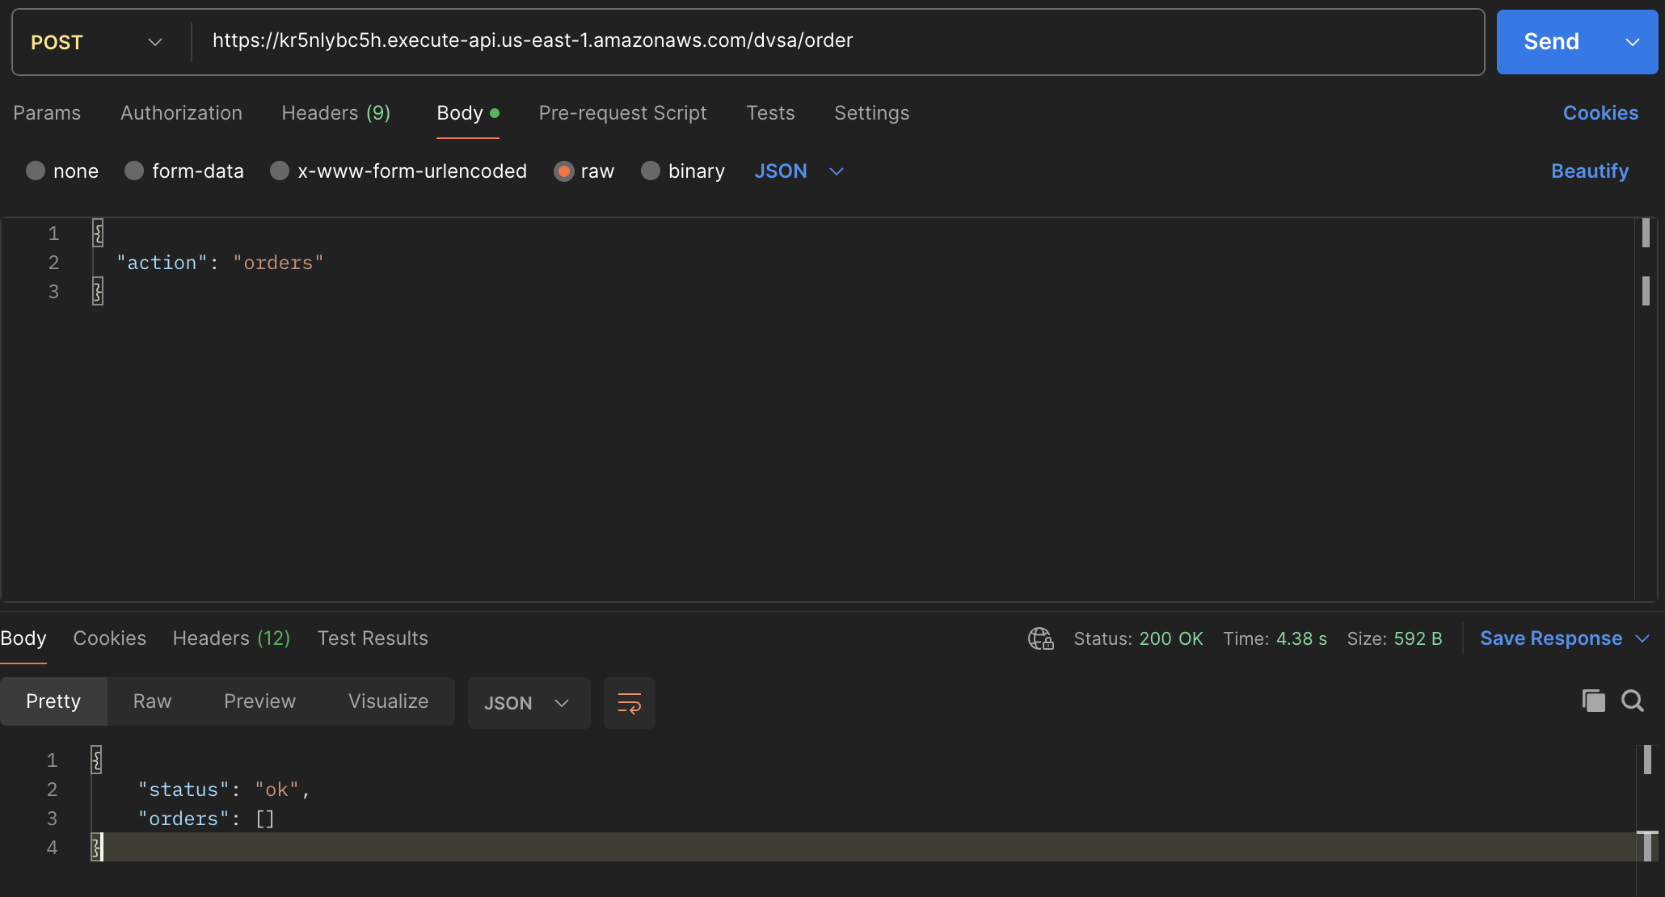
Next, the attacker modifies the request by injecting a malicious serialized payload into an additional field:
{
“action”: “orders”,
“test”: “_$$ND_FUNC$$_function(){throw ‘INJECTEDbyMK’}()”
}
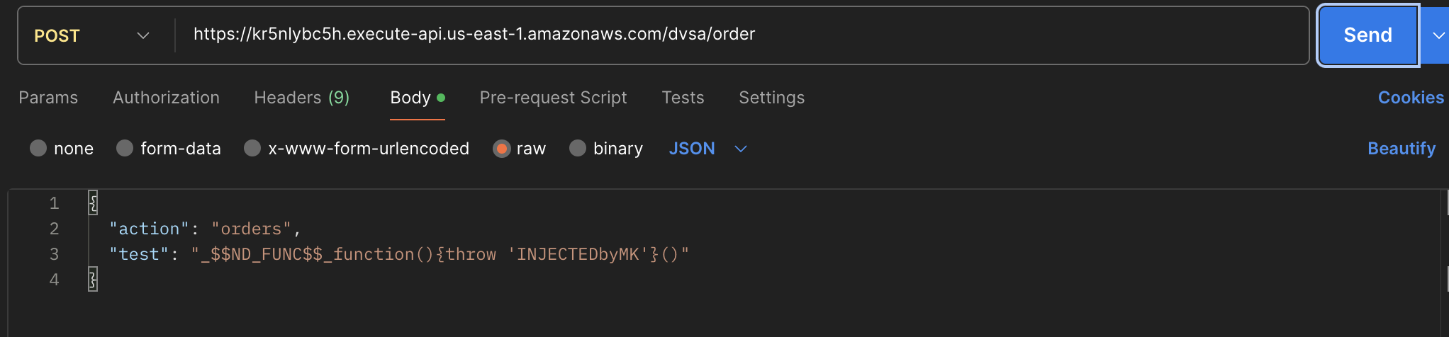
The attacker sends this crafted request to the same API endpoint using Postman. After sending the request, the API returns a 502 Bad Gateway error, indicating that the backend Lambda function encountered an internal failure.
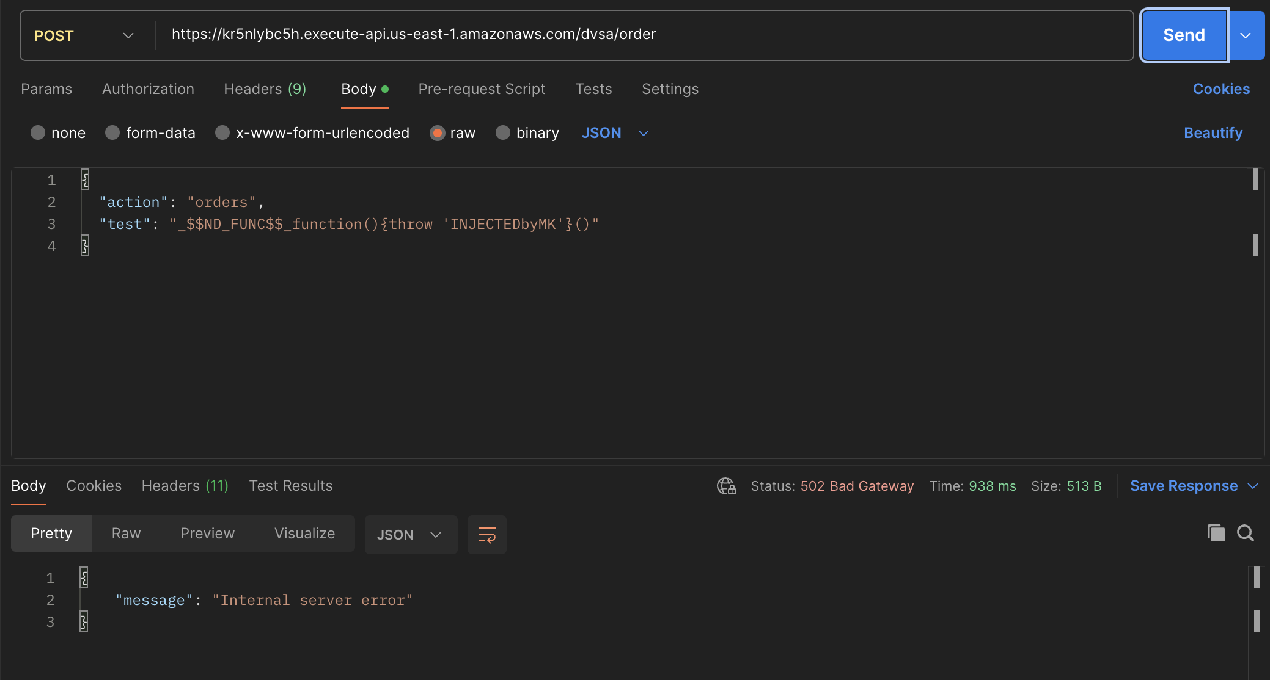

Finally, the attacker checks AWS CloudWatch Logs for the Lambda function handling the request. The logs show that the injected function was executed, and the custom error message INJECTEDbyMK appears in the stack trace.
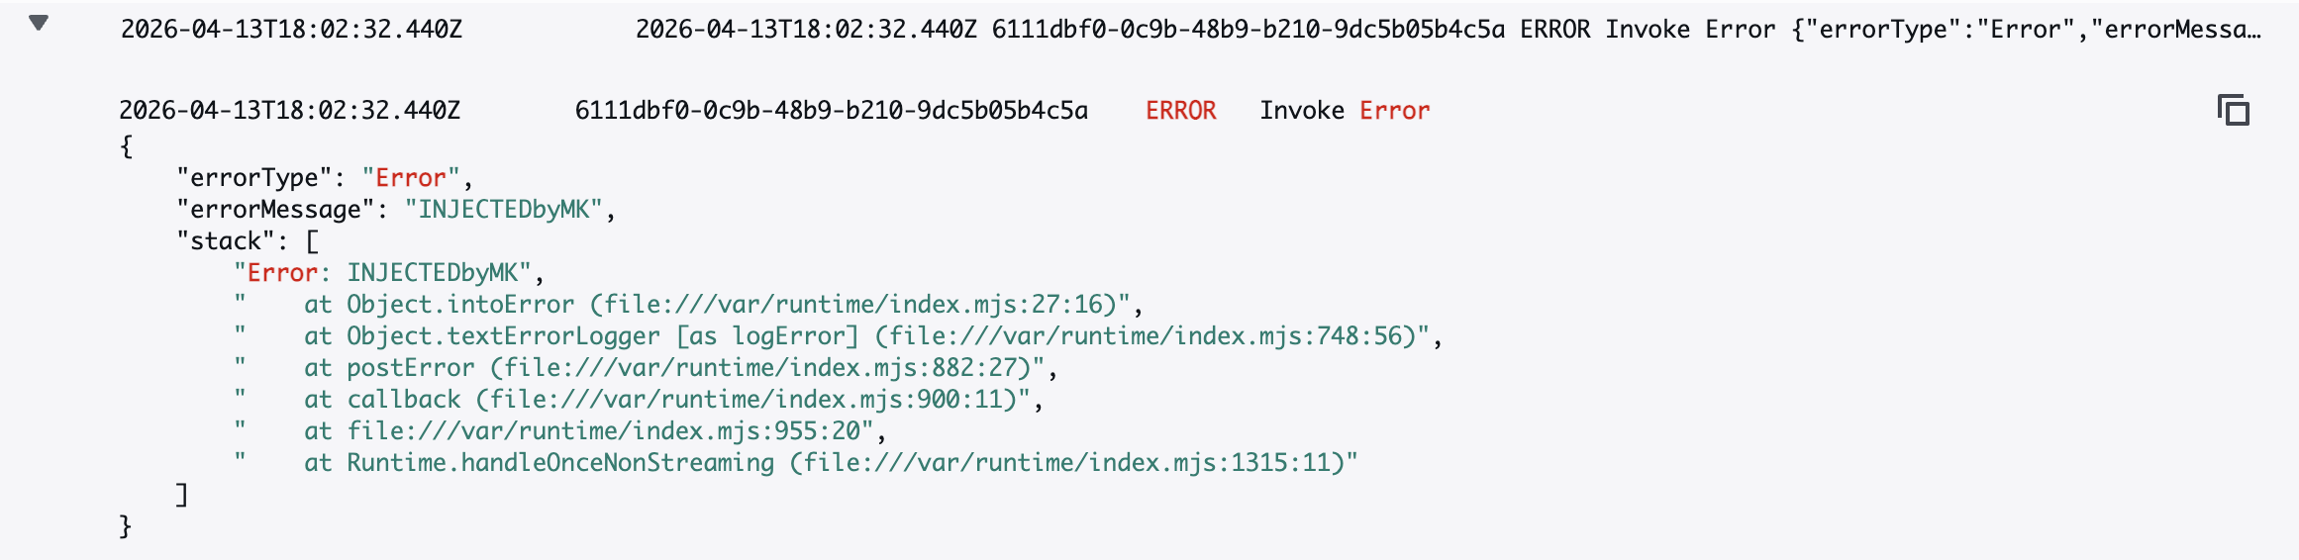

Evidence and Proof

The vulnerability is confirmed by the fact that attacker-controlled input is executed inside the Lambda runtime. The key evidence is the CloudWatch log entry showing:
“errorMessage”: “INJECTEDbyMK”
This message originates directly from the injected payload, proving that the function defined in the request body was executed by the backend.
Additionally:
- A normal request returns a valid response
- The malicious request causes a backend failure
- The injected error message appears in CloudWatch logs

The exploit is further validated by the fact that the injected payload produced a controlled and predictable error message inside the Lambda execution environment. The appearance of the exact attacker-defined string confirms that the backend interpreted user input as executable code rather than plain data. This combination of results demonstrates that the backend treats user input as executable content, confirming the presence of an Event Injection vulnerability.

Fix Strategy / Probable Mitigation

The appropriate fix for this vulnerability is to eliminate unsafe deserialization of untrusted input. The application must never use node-serialize on request data received from users.
Instead, request bodies should be treated strictly as JSON and parsed using safe methods such as JSON.parse. Additionally, all input fields should be validated against an allowlist to ensure that only expected data types and formats are accepted.
The backend should also enforce strict separation between data and executable logic, ensuring that user input cannot influence code execution in any way. In addition, dependency-level security must be considered, as the use of vulnerable libraries such as node-serialize introduces systemic risks. Replacing such libraries with secure alternatives is essential. xAdditionally, vulnerable dependencies such as node-serialize and node-jose should be removed or updated to eliminate known security risks.

Code / Config Changes

To fix the vulnerability, the request-processing logic in the AWS Lambda function was modified to remove the use of node-serialize for handling request data.

Before the fix, the application used:
var req = serialize.unserialize(event.body);
var headers = serialize.unserialize(event.headers);
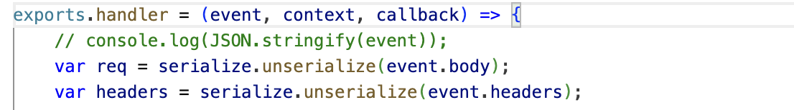

After the fix, this logic was replaced with safe JSON parsing:
const req = JSON.parse(event.body || “{}”);
const headers = event.headers || {};

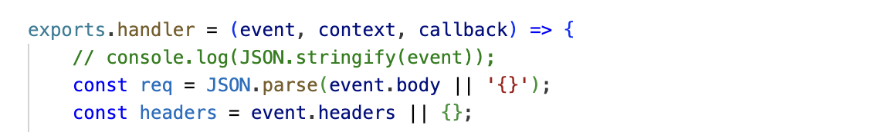
The main logic changes were:
- Removing unsafe deserialization using node-serialize
- Treating request data strictly as JSON
- Preventing execution of user-controlled content

Verification After Fix

After applying the fix, the same exploit payload was sent again:
{
“action”: “orders”,
“test”: “_$$ND_FUNC$$_function(){throw ‘INJECTEDbyMK’}()”
}
This time, the backend processed the request without executing the payload. The request either returned a normal response or rejected the malformed input without triggering an internal error.

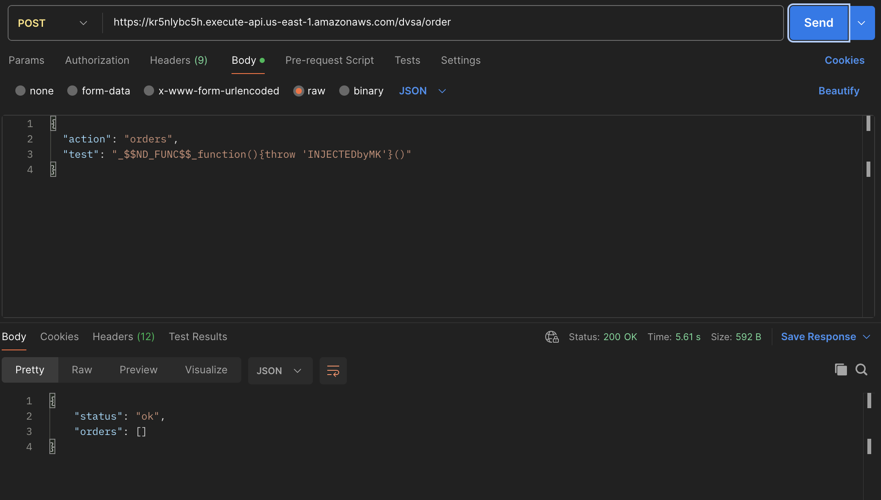
CloudWatch logs confirmed that no injected code was executed and no custom error message appeared.

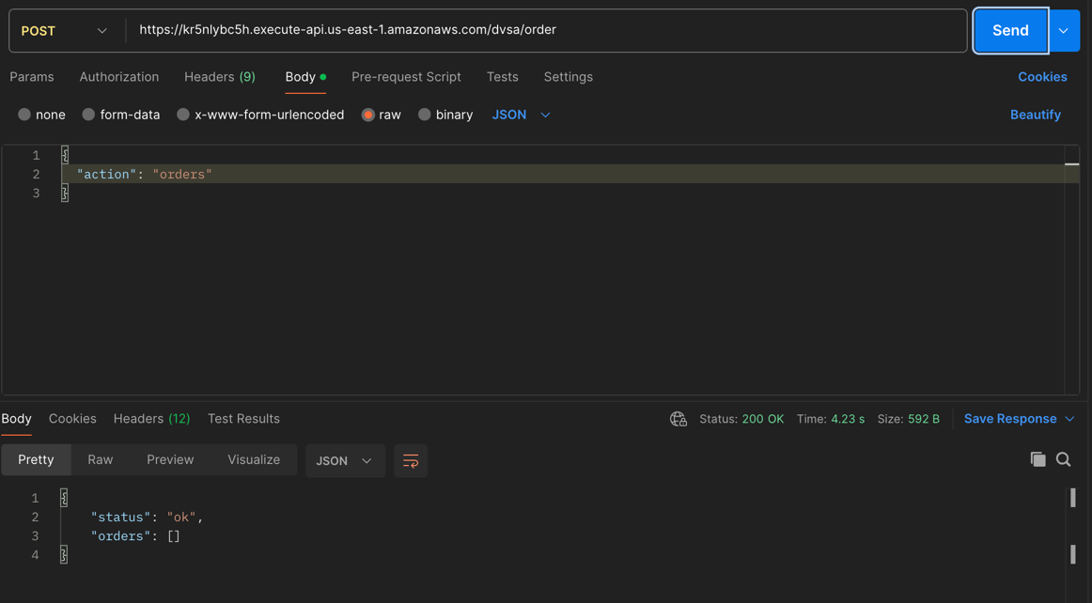
Additionally, normal requests using valid input continued to work correctly.

Structured Operation and Security Analysis

1) Intended Logic and Security Rule(s)
Under normal conditions, a user sends a request through API Gateway, which forwards the request to the Lambda function. The Lambda function should parse the request body as plain JSON, validate input fields, and process the requested action.

The main security rules are:
- The system must treat user input strictly as data, not executable code
- The system must not execute any content derived from user input
- The system must validate all request fields before processing

2) Evidence Sources and Behavior Trace
The analysis was based on:
- API requests and responses (Postman)
- Browser DevTools
- AWS CloudWatch Logs

Behavior comparison:
Normal Behavior:
Valid request returns expected results.

Exploit Behavior:
Crafted payload executes during deserialization and produces custom error (INJECTEDbyMK).

Post-Fix Behavior:
Injected payload is no longer executed and the system behaves safely.

3) Deviation Analysis and Classification

The exploit behavior represents a clear deviation from intended system behavior. Instead of treating request input as plain data, the system executes attacker-controlled code during deserialization.This violates the rule that user input must never influence code execution.
This case is classified as:Intentional misuse / security-relevant abuse

4) Explainable Fix and Post-Fix Validation

The incorrect assumption in the system was that deserializing request input using node-serialize is safe. This assumption is invalid because the library supports execution of serialized functions. The fix removes unsafe deserialization and enforces strict JSON parsing.
Post-fix testing confirms that:
- Malicious payloads are no longer executed
- No custom errors appear in logs
- Normal functionality remains intact

Vulnerability | Intended Rule(s) | Artifacts Used to Infer Rule | Normal Behavior Evidence | Exploit Behavior Evidence
Event Injection | User input must be treated strictly as data and must never be executed as code | API requests (Postman), CloudWatch logs, Lambda source code | Valid request returns normal response | Injected payload executes and produces custom error in logs (INJECTEDbyMK)

Vulnerability | Why This Is a Deviation | Deviation Class | Fix Applied (Where) | Post-Fix Verification
Event Injection | The system executes attacker-controlled input during deserialization, violating input-handling rules | Intentional misuse / security-relevant abuse | Removed node-serialize in Lambda request handler and replaced with JSON parsing | Payload no longer executes; system behaves normally after fix

________________________________________
5) Lesson 9: Vulnerable Dependencies

This lesson highlights the security risks introduced by vulnerable third-party dependencies used in the DVSA application.
The application relies on multiple external libraries, including node-serialize and node-jose, both of which have known security vulnerabilities.
The node-serialize library is critically vulnerable because it allows execution of serialized functions using the _$$ND_FUNC$$_ pattern. This vulnerability was directly exploited in Lesson 1, where attacker-controlled input was executed within the Lambda environment. This demonstrates how a vulnerable dependency can lead to remote code execution.
In addition, the application uses node-jose, which has several documented vulnerabilities, including:
• Invalid Curve Attack
• Regular Expression Denial of Service (ReDoS)
• Potential command injection through dependent libraries
Although these vulnerabilities were not exploited in this demonstration, their presence increases the overall attack surface and risk level of the system.
This lesson reinforces the importance of secure dependency management. Applications must:
• Regularly scan dependencies for vulnerabilities
• Update or replace insecure libraries
• Avoid using libraries that execute dynamic or untrusted input
The root cause of the exploit demonstrated in Lesson 1 is directly tied to the use of node-serialize, making it a clear example of how vulnerable dependencies can compromise application security.

Takeaway / Lessons Learned

This lesson demonstrates how unsafe deserialization can introduce critical vulnerabilities in serverless applications. By allowing user input to be interpreted as executable code, the system exposes itself to arbitrary code execution within the Lambda environment. This significantly increases the potential blast radius, as attackers may gain access to environment variables, internal services, or other AWS resources through the function’s execution role.
The root cause highlights the importance of secure dependency management and strict input handling. Libraries that support dynamic execution should never be used on untrusted input. Instead, all request data must be treated strictly as data and validated using allowlists and safe parsing methods.

